**ASSIGNMENT NO:05-Group A**

Name:Mrunal R Somankar

Roll No:TCOA46

**C code:-**

#include <jni.h>

#include<stdio.h>

#include"B1.h"

JNIEXPORT int JNICALL Java_B1_add(JNIEnv *env , jobject obj,jint a,jint b)

{

printf("\n%d + %d = %d\n",a,b,(a+b));

return ;

}

JNIEXPORT int JNICALL Java_B1_sub(JNIEnv *env , jobject obj,jint a,jint b)

{

printf("\n%d - %d= %d\n",a,b,(a-b));

return ;

}

JNIEXPORT int JNICALL Java_B1_mult(JNIEnv *env , jobject obj,jint a,jint b)

{

printf("\n%d * %d = %d\n",a,b,(a*b));

return ;

}

JNIEXPORT int JNICALL Java_B1_div(JNIEnv *env , jobject obj,jint a,jint b)

{

printf("\n%d / %d = %d\n",a,b,(a/b));

return ;

}

**Java code:-**

import java.io.*;

import java.util.*;

class B1 {

static{

System.loadLibrary("B1");

}

private native int add(int a,int b);

private native int sub(int a,int b);

private native int mult(int a,int b);

private native int div(int a,int b);

public static void main(String[] args)

{

Scanner sc = new Scanner(System.in);

int a ,b ,ch;

System.out.println("\nEnter the value of A: ");

a = sc.nextInt();

System.out.println("\nEnter the value of B: ");

b= sc.nextInt();

do {

System.out.println("\nEnter the choice:");

ch= sc.nextInt();

switch(ch)

{

case 1 : new B1().add(a,b);

break;

case 2 : new B1().sub(a,b);

break;

case 3 : new B1().mult(a,b);

break;

case 4 : new B1().div(a,b);

break;

default : System.out.println("Your choice is Wrong !");

}

}while(ch<5);

}

}

**C header file:-**

/* DO NOT EDIT THIS FILE - it is machine generated */

#include <jni.h>

/* Header for class B1 */

#ifndef _Included_B1

#define _Included_B1

#ifdef __cplusplus

extern "C" {

#endif

/*

* Class: B1

* Method: add

* Signature: (II)I

*/

JNIEXPORT jint JNICALL Java_B1_add

(JNIEnv *, jobject, jint, jint);

/*

* Class: B1

* Method: sub

* Signature: (II)I

*/

JNIEXPORT jint JNICALL Java_B1_sub

(JNIEnv *, jobject, jint, jint);

/*

* Class: B1

* Method: mult

* Signature: (II)I

*/

JNIEXPORT jint JNICALL Java_B1_mult

(JNIEnv *, jobject, jint, jint);

/*

* Class: B1

* Method: div

* Signature: (II)I

*/

JNIEXPORT jint JNICALL Java_B1_div

(JNIEnv *, jobject, jint, jint);

#ifdef __cplusplus

}

#endif

#endif

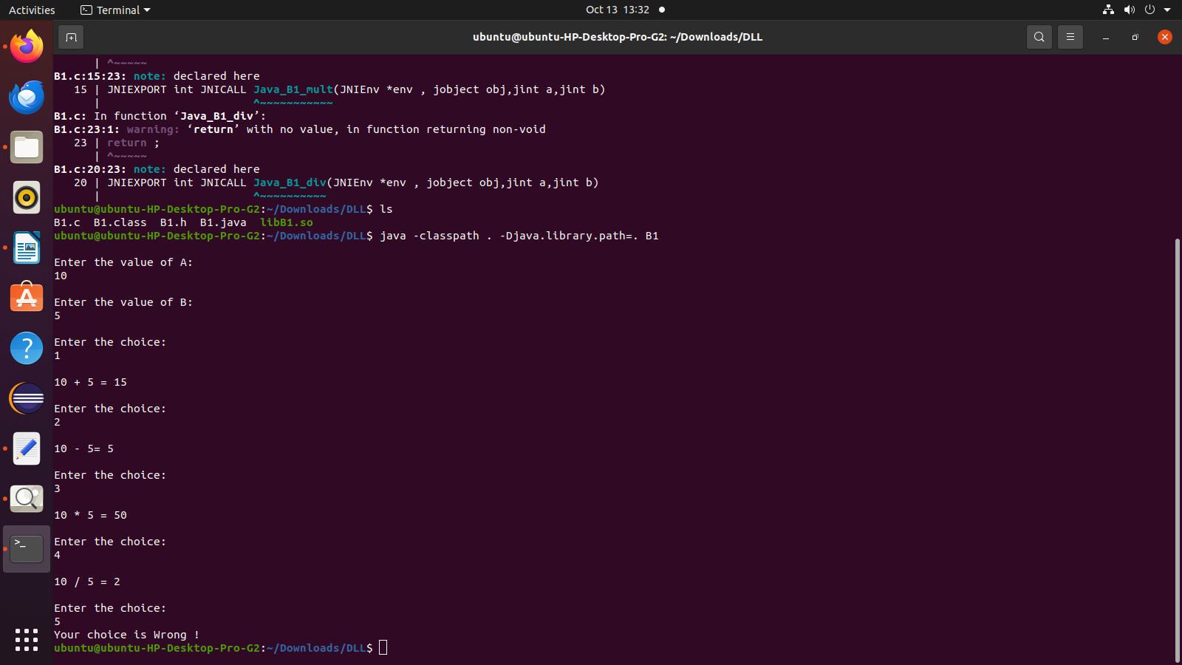**Output:-**